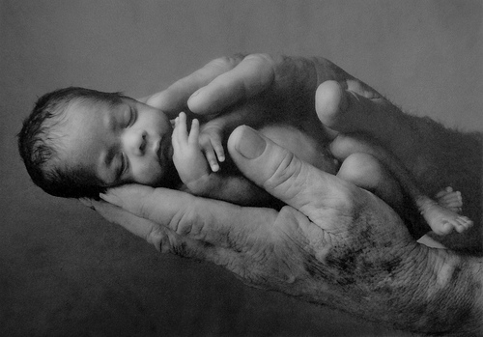
Second Annual “All About the Family” Gala
Saturday, October 22, 2016
Aqua Caliente Hotel and Casino
Check in and registration starts at 5:30 PM
Reception & Silent Auction, 5:30-7:00 PM
Dinner, Live Auction & Entertainment by “New Sensations Band” 7:00-11:30

Registration options: Mail signed reply form to:
Hanson House, c/o NICU Fundraiser
380 E. Paseo, El Mirador
Palm Springs, CA 92262
Fax to (760) 416-5071 Hanson House, c/o NICU Fundraiser Any questions call Donna King, Executive Director at 760-238-0040

Sponsor Name as you want it to appear______________________________________
Address________________________________________City, State, Zip__________________________________
Phone__________________________________________Email_________________________________________

Corporate Sponsor Registration level (All sponsorships will be included in program, on table, and slide show)
⃝Silver Sponsor, $500 (2 guests)
⃝Gold Sponsor, $1000 (4 guests)
⃝Platinum, $2000 (6 guests)
⃝Diamond, $3000 (10 guests)

⃝Individual Sponsor (10 guests x $150)

⃝Individual tickets $150 x ____ (quantity)

⃝ I/We cannot attend but would like to make a contribution in support of the NICU families at Hanson House
$_____________

⃝ I/We would like to donate an item for your auction _______________

PAYMENT METHOD
⃝ Please charge $ _________ to (select one) Visa Mastercard American Express Discover
Card Number_______________________________________________Expiration date_____________
Name on Card______________________________________________Security Code_______________
Signature____________________________________________________________________________

⃝ Enclosed is my check for $______________(checks payable to Hanson House c/o NICU)
⃝ I pledge to fulfill my sponsorship commitment by sending payment by October 8th, 2016
Signature ______________________________ Date_________________
Hanson House Foundation, Inc. is an IRS approved not-for-profit 501(c) 3 organization tax ID# 20-0028619.

